Top 10 Secure Coding Practices from the Computer Emergency Response Team (CERT)

**1. Validate Input**

All input from untrusted sources, such as users, must be validated to ensure it is safe and expected. Input validation helps prevent attacks like **SQL injection** or **cross-site scripting (XSS)**, where malicious input can lead to severe vulnerabilities.

**2. Heed Compiler Warnings**

Compilers often produce warnings about potential problems in code, such as **buffer overflows** or uninitialized variables. Developers should fix these warnings because ignoring them might introduce vulnerabilities. Enabling strict compiler warnings and using tools like static analyzers can help improve code quality.

**3. Architect and Design for Security Policies**

Security must be a consideration during the design phase, not just an afterthought. This involves creating **security policies** that outline how the system should protect sensitive data, manage access, and handle exceptions. A secure architecture prevents the introduction of design flaws that attackers could exploit.

**4. Keep It Simple**

Complex code is harder to audit, maintain, and secure. By following the principle of **simplicity**, developers reduce the likelihood of introducing obscure bugs or security flaws. Simple designs are easier to test and secure.

**5. Default to Deny**

Access controls should be set to **deny by default** . This minimizes the attack surface by limiting permissions to the bare minimum necessary for the system to function, reducing the risk of unauthorized access.

**6. Adhere to the Principle of Least Privilege**

Give users, processes, and applications the **minimum level of access** they need to perform their tasks. For example, a user should not have administrative access unless required, and applications should run with the lowest privileges possible, reducing potential damage from an exploit.

**7. Sanitize Data Sent to Other Systems**

Ensure that any data sent to other systems, including databases, web services, or other applications, is **sanitized** to remove potentially harmful elements. This prevents **command injection** attacks, where attackers manipulate input data to execute unintended commands.

**8. Practice Defence in Depth**

Use multiple layers of security controls to protect the system. This **defense-in-depth** strategy ensures that if one control fails, additional layers of security can mitigate the threat. This could include firewalls, encryption, intrusion detection systems, and secure coding practices.

**9. Use Effective Quality-Assurance Techniques**

Employ **quality-assurance techniques** such as **code reviews**, **automated testing**, **pen test ,buzz test** and **static/dynamic analysis** to detect vulnerabilities early in the development cycle.

**10. Adopt a Secure Coding Standard**

Follow a recognized **secure coding standard**. Adopting a secure coding standard ensures consistency across the development team.

**Control hijacking** attacks are a type of cyber attack where the attacker takes control of a program’s execution flow and directs it to malicious code, which can result in a wide range of security issues, system manipulation, and further exploitation.

A **buffer overflow attack** is a type of security exploit where an attacker intentionally writes more data to a buffer (a temporary storage area in memory) than it can hold. This causes the excess data to overflow into adjacent memory, potentially overwriting critical program data, control structures, or even executable code. By doing so, the attacker can manipulate the program’s execution, leading to unexpected behavior, crashes, or the execution of malicious code.

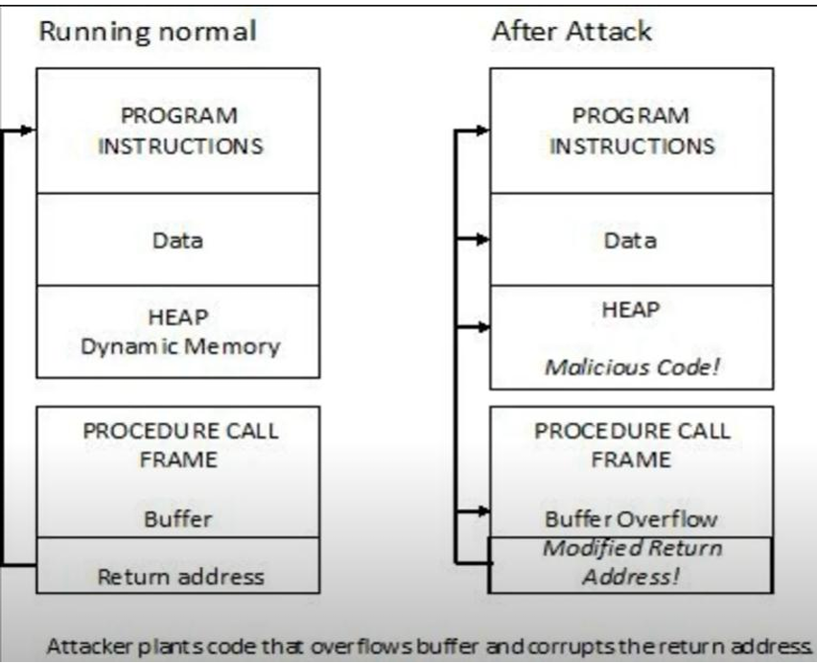

**Buffer overflow** is a result of **insufficient boundary** checks when inserting data to a buffer. If we insert more data than the buffer holds, a buffer overflow occurs. It is easy, it is simple, but it is dangerous and the results from it might be severe.  
  
**Prevent:**

• **Bounds Checking**:

* Properly validate the size of inputs before copying them into buffers. Ensure that the buffer can handle the amount of data being written to it.
* Functions like strcpy() or gets() in C are unsafe because they don’t check input size. Safer alternatives include strncpy() and fgets().

• **Stack Canaries**:

* A **stack canary** is a known value placed just before the return address on the stack. If a buffer overflow occurs, the canary value will be overwritten. Before returning from a function, the program checks whether the canary value has changed. If it has, it means an overflow occurred, and the program will terminate or raise an alarm.

• **Data Execution Prevention (DEP)**:

* This is a security feature in modern operating systems that marks certain regions of memory (such as the stack) as non-executable. Even if an attacker manages to overwrite a return address, the injected malicious code cannot be executed because the stack is marked as non-executable.

• **Address Space Layout Randomization (ASLR)**:

* ASLR is a security technique that randomizes the memory locations of key data areas, such as the stack, heap, and libraries. This makes it harder for an attacker to predict memory addresses and successfully launch a buffer overflow attack.

• **Safe Programming Languages**:

* Use programming languages that automatically manage memory and enforce bounds checking, such as **Java** or **Python**, which are less prone to buffer overflows than languages like C or C++.

• **Compiler Defenses**:

* Modern compilers often have built-in protections against buffer overflow vulnerabilities. For example, GCC (GNU Compiler Collection) has options like -fstack-protector that help defend against stack-based buffer overflows

An **integer overflow attack** occurs when an attacker intentionally causes an integer overflow vulnerability in a program to manipulate its behavior, potentially leading to security breaches. This type of vulnerability is common in software that **doesn’t properly validate integer inputs** or calculations, especially when dealing with arithmetic operations that exceed the size of the variable used to store the result.

When an integer overflows, it wraps around to the minimum value representable by the type (for signed integers) or starts from zero again (for unsigned integers). This behavior can be exploited to bypass security checks, allocate insufficient memory, or even cause buffer overflows, which can allow attackers to execute arbitrary code.

PREVENTIONS:

• **Input Validation**:

* Always validate inputs, especially those that influence critical program variables like buffer sizes, loop counters, or memory allocations. Make sure inputs fall within expected ranges.

• **Use Larger Data Types**:

* Consider using larger integer types (such as uint64_t instead of uint32_t) for arithmetic operations that could potentially overflow smaller types. However, this is not a complete solution, as overflows can still occur with large types.

• **Compiler Warnings and Static Analysis**:

* Enable compiler warnings to detect potential overflow issues during development. Many compilers (e.g., GCC, Clang) can detect certain types of integer overflow at compile time.
* Use static analysis tools (e.g., Coverity, CodeSonar) to detect integer overflows and other vulnerabilities in the code.

• **Languages with Built-in Protection**:

* Use programming languages that offer built-in protections against integer overflow. For example, languages like **Rust** have optional checks that panic when integer overflows occur during arithmetic.

• **Testing and Fuzzing**:

* Use fuzz testing to input random, unexpected, or extreme values to your program, helping to uncover integer overflow vulnerabilities during testing.

In computer security, a **sandbox** is a security mechanism for separating running programs, usually in order to minimize system failures or software vulnerabilities from spreading.

In general, a sandbox is an isolated computing environment in which a program or file can be executed without affecting the application in which it runs. Sandboxes are used by software developers to test new programming code. Sandboxing is frequently used to test unverified programs that may contain a virus or other malicious code, without allowing the software to harm the host device.

**Importance of Sandboxes**

* Cybersecurity professionals use sandboxes to test potentially malicious software. Without sandboxing, an application or other system process could have unlimited access to all the user data and system resources on a network.
* Sandboxing protects an organization's critical infrastructure from suspicious code because it runs in a separate system. It also allows IT to test malicious code in an isolated testing environment to understand how it works within a system as well as more rapidly detect similar malware attacks.

**2. Isolation**

**Isolation** refers to separating different system components, processes, or users so that they have minimal interaction with each other, ensuring that a security compromise in one component doesn’t affect others. This principle is essential for achieving security in multi-user systems, cloud environments, and microservices architectures.

**Benefits of Isolation:**

* **Enhanced Security**: Isolation limits the potential impact of a compromised application, process, or user, preventing attacks from spreading across the system.
* **Fault Containment**: In the case of failures or vulnerabilities, isolation helps contain the damage to one component, reducing the likelihood of system-wide failure.
* **Data Privacy**: Isolating users ensures that one user cannot access or modify another user’s data, a critical requirement in multi-user systems and cloud environments.

**Program analysis (static, concolic and dynamic analysis)-**

**Program analysis** refers to techniques used to analyze and verify software programs in terms of their correctness, security, performance, and behavior. There are several forms of program analysis, including **static analysis**, **dynamic analysis**, and **concolic analysis**. Each approach has its unique strengths and use cases in identifying potential vulnerabilities or bugs in software.

**1. Static Analysis**

Static analysis refers to examining the source code of a program **without executing it**. It involves analyzing the program’s structure, control flow, and data flow to detect issues like security vulnerabilities, logical errors, and inefficiencies.

**Key Features:**

* **No execution required**: Static analysis tools examine the code without running the program. This makes it useful for identifying potential bugs and vulnerabilities early in the development process.
* **Source code or bytecode analysis**: Static analysis can work directly on source code, intermediate representations (like bytecode), or even compiled machine code.
* **Common checks**: These include checking for buffer overflows, memory leaks, null pointer dereferences, type mismatches, and adherence to coding standards.
* **Scalability**: Static analysis can be applied to very large codebases and is often integrated into development environments (IDEs).

**Example tools:**

* **SonarQube** (for code quality and security)
* **Clang Static Analyzer**
* **FindBugs/SpotBugs** (for Java code)

**2. Dynamic Analysis**

Dynamic analysis involves analyzing a program by **executing it in a real or simulated environment**. It observes the runtime behavior of the program to detect issues that might only surface during execution, such as memory corruption, crashes, and performance bottlenecks.

**Key Features:**

* **Real-time behavior monitoring**: Dynamic analysis observes how the program interacts with the system and inputs during execution. This includes memory usage, CPU performance, and error handling.
* **Test input generation**: Dynamic analysis is often used in conjunction with unit tests or test suites to exercise different parts of the program.
* **Coverage**: It provides insights into the parts of the code that are actually executed, helping to detect untested or dead code.

**Example tools:**

* **Valgrind** (for memory leaks, memory corruption in C/C++)
* **Purify** (runtime memory checking)
* **JaCoCo** (for Java code coverage)
* **Fuzz testing** (sending random inputs to detect unexpected behavior)

**3. Concolic Analysis (Concolic Testing or Symbolic Execution)**

**Concolic analysis** (a combination of **concrete** and **symbolic** analysis) is a hybrid technique that combines aspects of both static and dynamic analysis. The key idea is to **execute the program on concrete inputs while simultaneously generating symbolic expressions** for variables based on the path the program takes during execution. This allows the analysis to explore multiple execution paths by generating new inputs for paths that were not previously covered.

**Key Features:**

* **Concrete and symbolic execution**: The program is executed with specific inputs (concrete execution), while symbolic expressions for variables and decisions are also generated. These expressions are used to identify and explore other potential execution paths (symbolic execution).
* **Automated test generation**: Concolic analysis can automatically generate new test inputs that force the program to explore previously unexplored paths, improving test coverage.
* **Path exploration**: concolic testing can explore alternative branches in the code (e.g., if conditions) that would be missed by traditional dynamic analysis.

**Example tools:**

* **KLEE** (for symbolic execution of C programs)
* **SAGE** (a Microsoft tool used for concolic testing)
* **CBMC** (a bounded model checker with concolic capabilities)

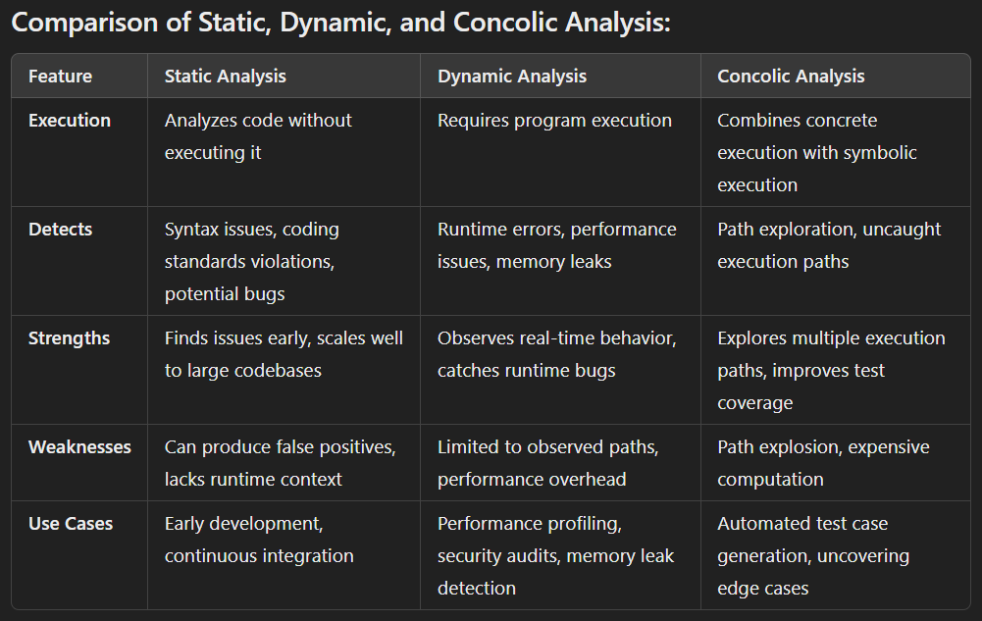

**1. Privileges**

Privileges refer to the rights or permissions granted to users or processes to perform specific actions on a system. These actions might include reading or writing files, executing programs, or modifying system configurations.

* **User privileges**: Operating systems often classify users into different privilege levels. For example, in Unix-based systems, there’s a distinction between a regular user and the **root** (administrator) user. Regular users have limited access, while root users have full control over the system.
* **Process privileges**: Processes also run with different privilege levels, which dictate what system resources they can access or modify. It's important that processes are granted only the necessary privileges to reduce the impact of vulnerabilities or security breaches.

A key security principle here is the **Principle of Least Privilege (PoLP)**, which mandates that users or processes should be given the minimal level of access required to perform their function, reducing the potential damage if they are compromised.

**2. Access Control**

Access control refers to the mechanisms that regulate who can access certain resources or perform specific actions within a system. It ensures that only authorized users or processes have access to certain files, networks, or services.

There are various **models of access control**:

* **Discretionary Access Control (DAC)**: The owner of a resource (e.g., a file) has the discretion to control who can access it. This model gives users control but may lead to security risks if users make incorrect choices about permissions.
* **Mandatory Access Control (MAC)**: Access is controlled by the system itself, based on predefined policies. Users or processes are assigned security labels, and the system strictly enforces who can access what, based on these labels. MAC is often used in high-security environments.
* **Role-Based Access Control (RBAC)**: Access rights are granted based on a user's role in an organization. For instance, an HR department employee might have different access permissions than someone in IT, even if both are on the same network.
* **Attribute-Based Access Control (ABAC)**: Access decisions are made based on user attributes (such as department, clearance level, etc.) combined with rules and policies. ABAC is more dynamic and flexible compared to RBAC.

Effective access control is crucial for preventing unauthorized access and minimizing security breaches.

**3. Operating System Security**

Operating System (OS) security involves the protection of the OS from threats like malware, unauthorized access, and exploits. It’s vital because the OS manages all hardware resources and acts as the backbone for running applications.

Key aspects of OS security include:

* **User authentication**: Verifying user identities before granting access. Methods include passwords, biometrics, or multi-factor authentication.
* **Process isolation**: Ensuring that each process runs in its own space (e.g., using memory management techniques like virtual memory), preventing one process from accessing or tampering with the memory of another. This reduces the chance of exploitation if a process becomes compromised.
* **Encryption**: Operating systems often offer encryption mechanisms to secure data at rest (stored data) and in transit (data moving between systems). Full-disk encryption can protect data even if the physical device is stolen.
* **Patch management**: Operating systems frequently have vulnerabilities, so applying security updates or patches is essential to prevent exploitation by attackers.
* **Auditing and logging**: OS security systems maintain detailed logs of user activity, process execution, and other events. This helps detect anomalies and potential security incidents.
* **Security features**: Most modern OSes include built-in security features like firewalls, intrusion detection systems, and access control mechanisms to guard against attacks.

A secure operating system plays a critical role in maintaining the overall security posture of any system or network.

**4. Exploitation Techniques**

Exploitation techniques are methods that attackers use to take advantage of vulnerabilities in software, hardware, or operating systems to gain unauthorized access, execute malicious code, or cause damage.

Some common **exploitation techniques** include:

* **Buffer Overflow**: Attackers exploit software bugs where too much data is written into a buffer (memory region), overwriting adjacent memory, which could allow them to inject and execute arbitrary code with the privileges of the compromised program.
* **Privilege Escalation**: This occurs when an attacker gains higher access rights than they should have. For instance, a regular user may find a vulnerability that allows them to gain administrator (root) access to a system.
* **Code Injection**: In this technique, attackers inject malicious code into a vulnerable application, which then executes it. Examples include **SQL injection** (in web applications) or **command injection** in server environments.
* **Cross-Site Scripting (XSS)**: A web-based attack where malicious scripts are injected into webpages viewed by other users. These scripts can steal cookies, session tokens, or other sensitive information from users.
* **Denial-of-Service (DoS) Attack**: The attacker makes a system unavailable to legitimate users by overwhelming it with fake requests or data, causing the system to crash or slow down.
* **Return-Oriented Programming (ROP)**: A sophisticated exploitation technique where an attacker uses existing code snippets in the memory (called “gadgets”) to execute malicious operations without injecting new code. This is used to bypass certain security mechanisms like Data Execution Prevention (DEP).
* **Social Engineering**: Though not a technical exploit, attackers often trick users into divulging confidential information (e.g., phishing) or perform actions that can compromise security.

Understanding these techniques helps security professionals design better defenses to safeguard systems from potential attacks. Regular security audits, penetration testing, and keeping software up-to-date can significantly reduce the risk of these exploitations.

**Fuzzing (also known as fuzz testing)** is a software testing techniqueused to discover vulnerabilities, bugs, or unexpected behavior in software by providing it with a wide range of malformed, unexpected, or random input data. The goal of fuzzing is to identify how a system behaves under unexpected conditions and to find security vulnerabilities, such as crashes, memory leaks, or unhandled exceptions.

Workflow::

• **Input Generation**: Select the specific fuzzer or fuzzing tools to generate random, malformed, or unexpected input data. This can range from slightly corrupted to completely nonsensical values, depending on the target and fuzzing strategy.

• **Input Injection**: The generated input is fed into the program or system being tested, typically by automating input through APIs, file parsing, or network communication.

• **Monitor Program Behavior**: The program's behavior is monitored closely to detect anomalies like crashes, memory corruption, or unexpected outputs.

• **Logging Results**: When unexpected behavior occurs, fuzzing tools log the specific input that caused the issue. This helps developers identify and debug the problem.

**Fuzzing Types**

* **Black-box fuzzing**: This approach treats the program as a black box, meaning it does not have any knowledge of the internal structure of the program. Black-box fuzzers generate random inputs and observe the program’s behavior. They are easy to use and versatile but may not be as effective at finding complex bugs as other methods.
* **White-box fuzzing**: This technique involves analyzing the program’s source code to generate input data. White-box fuzzers can create more targeted and relevant input data, making them more effective at finding intricate errors and vulnerabilities. However, they require more setup and processing time compared to black-box fuzzers.
* **Grey-box fuzzing**: This method combines elements of both black-box and white-box fuzzing. Grey-box fuzzers gather partial information about the program’s structure and execution, allowing them to balance efficiency and effectiveness. They are particularly useful for achieving higher code coverage and discovering more bugs without the extensive setup required by white-box fuzzers.

TOOLS 🡪

* SPIKE
* Radamsa
* Boofuzz
* Bfuzz
* Powerfuzzer

UNIT 2

**Privilege Separation** is a security principle in system design and architecture that involves dividing processes, users, or components into distinct entities with different privilege levels. This approach minimizes the potential attack surface of a system by ensuring that sensitive operations are handled by trusted components while less sensitive operations are executed with reduced privileges. The goal is to limit the impact of security breaches and enhance overall system security.

**Key Concepts of Privilege Separation:**

1. **Least Privilege**: This principle states that each process or user should have only the minimum privileges necessary to perform its intended functions. By limiting access, the risk of misuse or exploitation is reduced.
2. **Isolation**: Privilege separation helps isolate critical system components from less trusted ones. If an attacker compromises a less privileged component, they are less likely to gain access to sensitive data or critical system functions.
3. **Reduced Attack Surface**: By separating privileges, the overall attack surface is minimized. Attackers have fewer opportunities to exploit vulnerabilities within high-privilege components.
4. **Auditing and Monitoring**: Different components can be monitored separately, making it easier to track actions and identify suspicious behavior. This can enhance incident detection and response.

A **threat** is any potential danger or malicious event that could harm a system, network, or application. It can originate from various sources, including hackers, malware, system failures, or natural disasters.**Examples of Threats:**

* A hacker attempting to steal sensitive data.
* Malware designed to exploit a system’s weakness.
* Insider threats from employees with malicious intent.

A **vulnerability** is a weakness or flaw in a system, application, or network that could be exploited by a threat to compromise security. A vulnerability represents **where the threat can happen**.

**Examples of Vulnerabilities:**

* A software bug that allows buffer overflow.
* A weak password policy that makes it easier for attackers to gain unauthorized access.
* Unpatched software with known security holes.

**ATTACKS AND THEIR TYPES:-**

**1. Passive Attacks:**

In a **passive attack**, the attacker **monitors** or **eavesdrops** on the communication or system without altering or interfering with its operation. The goal is usually to gather information or intelligence. These attacks are often stealthy and difficult to detect because the system's functionality is not disrupted.

**Types of Passive Attacks:**

* **Interception Attack**: This involves unauthorized access to data being transmitted, such as eavesdropping on network traffic to intercept sensitive information (e.g., login credentials, emails, or credit card details). The attacker can tap into a communication channel but does not modify the data.
* **Traffic Analysis Attack**: In this attack, the attacker monitors the patterns and timing of communication rather than the actual contents. Even if the data is encrypted, the attacker can analyze the frequency, volume, or timing of transmissions to infer useful information about the sender and receiver's activities or intentions.

**Characteristics of Passive Attacks:**

* **No modification** of the data.
* **Difficult to detect** because the system is not altered.
* Mainly used for intelligence gathering (e.g., espionage, reconnaissance).

**2. Active Attacks:**

In an **active attack**, the attacker **modifies**, **disrupts**, or **destroys** the system's operation or communication. The goal of active attacks is often to cause harm, steal data, or manipulate systems by directly interfering with them. These attacks can be detected more easily than passive ones because they often cause noticeable disruptions or damage.

**Types of Active Attacks:**

* **Masquerade Attack**: The attacker impersonates a legitimate user or device to gain unauthorized access to systems or data. This could involve using stolen credentials or spoofing an IP address to appear as a trusted entity.
* **Interruption Attack**: The attacker disrupts the availability of a service or system by making it temporarily or permanently unavailable to authorized users. This could include attacks like physically cutting network cables or launching a Denial-of-Service (DoS) attack.
* **Fabrication Attack**: The attacker generates false information or injects fabricated data into a system. For example, generating fake emails or logs to mislead the system or its users.
* **Session Replay Attack**: The attacker intercepts and captures valid communication data (e.g., a session token) between two parties and later replays that data to impersonate one of the legitimate parties and gain unauthorized access.
* **Modification Attack**: The attacker alters data during transmission or within a system. This could involve changing a message’s content, modifying system configurations, or altering files to inject malicious code.
* **Denial of Service (DoS) Attack**: The attacker floods a system, server, or network with excessive traffic, overwhelming its resources and making it unavailable to legitimate users. A distributed denial-of-service (DDoS) attack uses multiple systems to launch the attack, making it harder to stop.

**Characteristics of Active Attacks:**

* **Direct interference** with system operations.
* Often **detectable** due to disruptions or changes in data.
* Can result in significant damage or data loss.

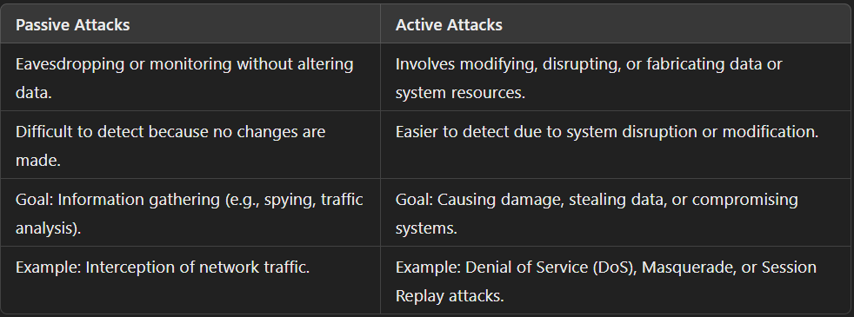

**1.** **Return-to-libc Attack**

**Definition:**

**Return-to-libc Attack** is used to exploit buffer overflow vulnerabilities on systems where stack memory is protected with no execute (NX) bit.

A **Return-to-libc** attack is an exploit technique used to bypass **non-executable stack protections** by making a program return to code in standard libraries (like libc) rather than executing malicious code directly injected by the attacker.

At a high level, ret-to-libc technique is similar to the regular stack overflow attack, but with one key difference - instead of overwritting the return address of the vulnerable function with address of the shellcode when exploiting a regular stack-based overflow with no stack protection, in ret-to-libc case, the return address is overwritten with a memory address that points to the function system(const char *command) that lives in the libc library, the program is forced to jump to the system() function and execute the shell command that was passed to the system() function .

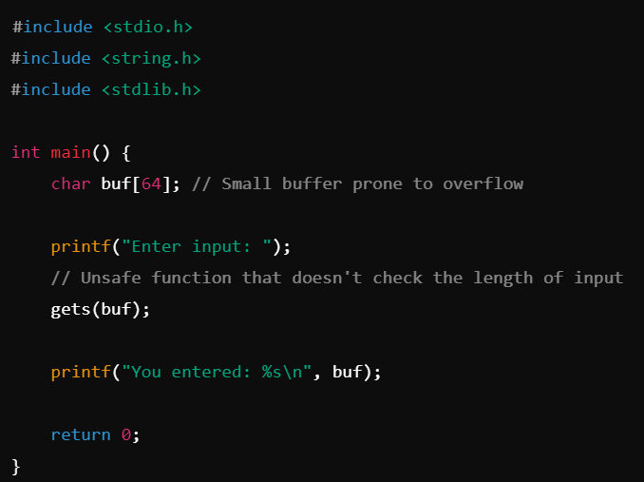

**How it Works:**

* The attacker could overflow the buffer and overwrite the return address to redirect the program’s execution flow to system() in libc, passing in /bin/sh to spawn a shell.
* The attacker carefully manipulates arguments to these functions to achieve malicious result.

**Prevention:**

* **Address Space Layout Randomization (ASLR)**: Randomizes memory addresses, making it harder for attackers to predict where libc functions are located.
* **Stack canaries**: Add checks for stack corruption, helping prevent overwriting return addresses.
* Using fgets(buf, sizeof(buf), stdin) in place of gets().

**2. Race Condition Vulnerability and Attack**

**Definition:**

A **race condition** vulnerability **occurs when multiple threads or processes access and manipulate shared data concurrently**, and the outcome of the execution depends on the particular order in which the access takes place. This can lead to unintended and potentially exploitable behavior.

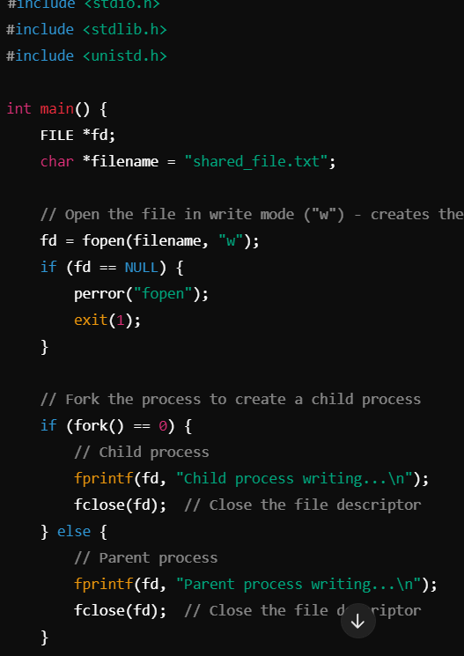

**How it Works:**

* Multiple processes or threads access shared resources (files, memory, etc.) simultaneously without proper synchronization.
* An attacker exploits this by racing two operations (e.g., checking file permissions and modifying the file) so that they happen in an unintended order. This allows them to alter program behavior or gain unauthorized access.

**Prevention:**

* **Locking mechanisms**: Use synchronization primitives (e.g., mutexes, semaphores) to ensure that critical sections of code are executed atomically.
* **Proper input validation**: Make sure shared resources are checked and used in an atomic (one-time) operation.
* **Avoiding time-of-check to time-of-use (TOCTOU) vulnerabilities** by rechecking conditions immediately before using shared resources.

**3. Dirty COW (Dirty Copy-On-Write)**

**Definition:**

The **Dirty COW** vulnerability is a well-known privilege escalation vulnerability that affects the **copy-on-write (COW)** mechanism in the Linux kernel. It allows an unprivileged user to gain write access to read-only memory mappings and modify files they should not be able to change, such as root-owned files.

The **Dirty COW attack** works by exploiting a race condition in the handling of COW pages.

**How it Works:**

* When a process requests a copy of some data (e.g., a file), the kernel does not create the actual copy until it's being written into. This technique is called copy-on-write (COW).
* The vulnerability allows an attacker to exploit a race condition in this COW implementation to write to a file or memory area marked as read-only.
* By triggering the race condition, an attacker can modify protected files (like /etc/passwd), giving themselves root privileges.

**Prevention:**

* **Patch the kernel**: Apply the security patches released after the discovery of Dirty COW.
* **Use hardened kernels**: Use kernel security extensions (like SELinux or AppArmor) that add additional layers of access control.

**4. Format String Vulnerability and Attack**

**Definition:**

A **Format String Vulnerability** occurs when untrusted input is passed as the format string parameter to functions like printf(), fprintf() **without proper validation or sanitization**. This allows an attacker to inject malicious format specifiers, which can be exploited to read or write arbitrary memory locations, execute arbitrary code, or cause a denial-of-service (DoS) condition

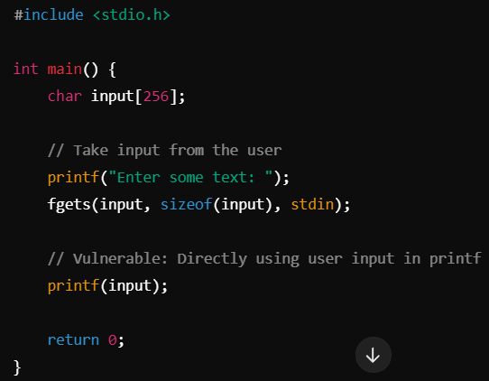

**How it Works:**

* Functions like printf() use format specifiers (%s, %x, %d, etc.) to output data.
* If an attacker can control the format string, they can use %x or %p to read memory values, and %n to write to memory locations, leading to potential **arbitrary code execution** or **information leaks**.

**Prevention:**

* **Use proper input validation**: Never directly pass untrusted input to format strings. Instead, use explicit format specifiers (printf("%s", userInput)).
* **Static analysis tools**: These can detect potential format string vulnerabilities in code.

**5. Heartbleed Vulnerability and Attack**

**Definition:**

**Heartbleed** is a vulnerability in OpenSSL's implementation of the **TLS/DTLS heartbeat** extension, which allows attackers to read memory from the affected server without proper authorization.

**How it Works:**

* The heartbeat mechanism is used to keep TLS connections alive by sending requests and receiving responses.
* Due to improper bounds checking, an attacker could send a malformed heartbeat request that specifies a larger-than-necessary payload size.
* This would cause the server to respond with more data than intended, potentially revealing sensitive information (e.g., private keys, session cookies, passwords) from server memory.

**Prevention:**

* **Update OpenSSL**: Apply patches to the OpenSSL library that fix the vulnerability.
* **Use secure libraries**: Regularly update cryptographic libraries and monitor for new vulnerabilities.

**6. Shellshock Vulnerability and Attack**

**Definition:**

**Shellshock** is a vulnerability in the Bash shell that allows attackers to execute arbitrary commands on a server by injecting malicious code into environment variables.

**How it Works:**

* Bash processes environment variables, and due to the vulnerability, Bash could interpret specially crafted environment variables as commands.
* Attackers could exploit this by passing malicious data via web servers (especially CGI scripts), remote services, or other Bash-executed scripts.
* This results in remote code execution, where the attacker can run arbitrary commands on the target system.

**Prevention:**

* **Update Bash**: Apply security patches to Bash that fix the Shellshock vulnerability.
* **Restrict Bash usage in scripts**: Avoid using Bash if possible or sanitize inputs passed to environment variables.
* **Firewalls and filters**: Implement network-level defenses to block malicious requests that attempt to exploit Bash.

**Web Security Model**

The **web security model** refers to the set of principles and technologies designed to secure interactions between users, web applications, and the underlying servers. It focuses on ensuring that data is safely transmitted and processed while preventing unauthorized access or manipulation.

Key components of the web security model include:

1. **Authentication**: Verifying the identity of users before granting them access to web resources (e.g., usernames/passwords, tokens, biometrics, multi-factor authentication).
2. **Authorization**: Determining what authenticated users are allowed to do (e.g., access control lists, role-based access control, least privilege principle).
3. **Confidentiality**: Ensuring that data sent over the network is not readable by unauthorized parties (e.g., TLS/SSL encryption, using HTTPS).
4. **Integrity**: Ensuring that the data is not tampered with during transmission or storage (e.g., cryptographic hashing, digital signatures).
5. **Non-repudiation**: Ensuring that parties involved in a communication cannot deny their actions (e.g., digital certificates, logging, and auditing).
6. **Session Management**: Properly managing user sessions, such as using secure session tokens or cookies, to prevent session hijacking.
7. **Data Validation**: Properly validating all user inputs to prevent attacks like SQL injection or cross-site scripting (XSS).
8. **Audit Logging**: Recording security-related events, such as login attempts or data access, to track malicious activities.

**Securing Web Applications**

Securing a web application involves using multiple layers of defense to protect against known attack vectors

• **Input Validation**

* Validate and sanitize all user inputs to ensure they conform to expected formats.
* Use whitelisting (allowed input types) rather than blacklisting (disallowed types).
* Implement server-side validation in addition to client-side validation.

• **SQL Injection Prevention**

* Use prepared statements or parameterized queries.
* Employ ORM frameworks that abstract and secure database queries.
* Regularly update and patch database management systems.

• **Cross-Site Scripting (XSS) Prevention**

* Use output encoding to escape special characters.
* Apply Content Security Policy (CSP) headers.
* Avoid dynamically inserting untrusted data into HTML pages or scripts without sanitization.

• **Cross-Site Request Forgery (CSRF) Prevention**

* Implement anti-CSRF tokens for sensitive requests.
* Require re-authentication for critical actions.
* Use SameSite cookies to limit the scope of cookies.

• **Strong Session Management**

* Use secure cookies (HttpOnly and Secure flags).
* Implement session timeouts and invalidate sessions appropriately.
* Rotate session tokens regularly.

• **Transport Layer Security (TLS)**

* Always use HTTPS to encrypt data in transit.
* Ensure TLS certificates are properly installed and up-to-date.
* Enforce HTTP Strict Transport Security (HSTS).

• **Error Handling and Logging**

* Avoid exposing detailed error messages to users.
* Log security-relevant events without exposing sensitive information.
* Use centralized log management with encryption.

• **Authentication and Authorization**

* Implement multi-factor authentication (MFA).
* Use strong, salted hashes for storing passwords.
* Apply the principle of least privilege.
* Regularly audit roles and permissions.

• **Security Headers**

* Implement Content-Security-Policy (CSP).
* Use X-Frame-Options to prevent clickjacking.
* Enable X-XSS-Protection.
* Set X-Content-Type-Options to prevent MIME type confusion.

• **Regular Security Testing**

* Perform regular vulnerability scans.
* Conduct penetration testing to simulate real-world attacks.
* Use fuzz testing to check application handling of unexpected inputs.

**UNIT 3**

**1. Same Origin Policy (SOP)**

The Same Origin Policy (SOP) is a web security mechanism implemented by browsers to restrict how documents or scripts from one origin can interact with resources from another. The "origin" is defined by the combination of domain, protocol, and port.

**Purpose**: SOP prevents malicious websites from accessing sensitive data on other websites. For example, a page from https://example.com cannot access cookies, DOM elements, or AJAX responses from https://bank.com.

**Importance**: SOP is essential to protect against attacks like Cross-Site Scripting (XSS) and Cross-Site Request Forgery (CSRF).

**Exceptions**: Legitimate cross-origin interactions can occur through mechanisms like Cross-Origin Resource Sharing (CORS), which explicitly allows controlled access between origins.

**Example**: If a user is logged into a banking website, SOP ensures that a malicious webpage cannot read their banking session data.

SOP forms the foundation of browser security by isolating websites, ensuring that sensitive information remains secure within its origin.

**2. Cross-Site Scripting (XSS) Attack**

Cross-Site Scripting (XSS) is a security vulnerability where attackers inject malicious scripts into trusted websites. These scripts execute in the victim’s browser, leading to theft of sensitive data, session hijacking, or redirection to malicious websites.

**Types**:

1. **Stored XSS**: Malicious scripts are permanently stored on the target server (e.g., in a database).
2. **Reflected XSS**: The payload is part of the request and reflected in the response, executed when a victim clicks on a link.
3. **DOM-Based XSS**: Scripts are executed due to vulnerabilities in the website's client-side scripts.

**Example**: A comment section on a website might allow the input of <script>alert('Hacked')</script>. If not sanitized, the script is executed when another user visits the page.

**Mitigation**: Input validation, output encoding, and using Content Security Policies (CSP) are effective defenses against XSS.

**3. Cross-Site Request Forgery (CSRF) Attack**

CSRF is a type of malicious exploit where an attacker tricks a user into submitting an unwanted action on a website or web application that the user is authenticated to.

**Mechanism**:

* The attacker embeds a malicious request in an email or third-party website.
* When the victim clicks the link or loads the malicious page, the browser sends the request using the victim’s session cookies.
* Example: A user logged into their bank is tricked into clicking a link that transfers funds to the attacker’s account.

**Impact**: Unauthorized actions like fund transfers, password changes, or email modifications can be performed.

**Mitigation**:

1. Anti-CSRF tokens: Unique tokens for each session to validate legitimate requests.
2. SameSite cookies: Prevent cookies from being sent with cross-site requests.
3. Referer header validation: Ensure requests come from trusted sources.

**4. SQL Injection Attack**

SQL Injection is a critical vulnerability where attackers execute malicious SQL queries by exploiting unsanitized inputs in web applications.

**Mechanism**: SQL commands are injected into input fields to manipulate the backend database.  
**Example**:

This bypasses authentication.

**Impact**:

1. Access to sensitive data.
2. Deletion or modification of database contents.
3. Potential control over the database server.

**Mitigation**:

1. Use parameterized queries and prepared statements.
2. Implement strict input validation.
3. Limit database privileges and implement robust error handling.

**5. Clickjacking Attack**

Clickjacking occurs when an attacker overlays an invisible iframe containing a legitimate webpage over a fake interface. When users interact with the visible interface, they unknowingly interact with the hidden iframe.

**Impact**:

1. **Stealing user actions**: Clicking a "Like" button, subscribing to a service, or making financial transactions.
2. **Unauthorized permissions**: Activating the webcam or microphone without consent.

**Example**: A user is tricked into clicking a button that appears to close a pop-up but actually triggers a payment action in the hidden iframe.

**Mitigation**:

1. **X-Frame-Options Header**: Prevents embedding the website in iframes.
2. **Frame-busting scripts**: Detect and block iframes attempting to overlay the site.
3. Content Security Policy (CSP): Restricts frame origins to trusted sources.

**6. Content Security Policies (CSP)**

Content Security Policy (CSP) is a security feature that helps prevent XSS, clickjacking, and other attacks by specifying which resources (scripts, styles, images) are allowed to load and execute.

**How it Works**: CSP is implemented via HTTP headers or meta tags.

**Benefits**:

1. Blocks unauthorized scripts.
2. Reduces attack surface for XSS.
3. Prevents data injection attacks.

**Challenges**: Misconfigured CSPs can reduce functionality or leave gaps in protection.

**7. Web Tracking**

Web tracking refers to the collection of data about a user’s online activity, including visited websites, clicks, and preferences.

**Techniques**:

1. **Cookies**: Store user data to track behavior across sessions.
2. **Browser Fingerprinting**: Identifies users based on unique browser settings and plugins.
3. **Tracking Pixels**: Invisible images that report user activity.

**Uses**:

1. Personalized advertisements.
2. Website analytics.
3. User experience improvement.

**Concerns**: Web tracking raises privacy issues, as users may not consent to data collection. Tools like ad blockers, privacy-focused browsers, and legislation like GDPR mitigate tracking.

**8. Session Management and User Authentication**

**Session Management** involves securely managing user sessions by assigning unique session identifiers (session IDs). These IDs track users' interactions with a web application.  
**User Authentication** verifies user identity using credentials like passwords, tokens, or biometrics.

**Best Practices**:

1. Securely store session IDs (e.g., in HttpOnly cookies).
2. Use HTTPS to encrypt session data in transit.
3. Implement Multi-Factor Authentication (MFA).

**Common Attacks**:

1. Session Hijacking: Stealing session IDs to impersonate a user.
2. Session Fixation: Forcing a user to use a known session ID.

**9. HTTPS**

HTTPS (HyperText Transfer Protocol Secure) encrypts communication between the browser and server using SSL/TLS protocols.

**Advantages**:

1. **Encryption**: Prevents data theft during transmission.
2. **Authentication**: Verifies that the website is genuine via SSL certificates.
3. **Integrity**: Ensures data has not been tampered with during transit.

**Implementation**: Websites obtain certificates from trusted Certificate Authorities (CAs). Modern browsers warn users about non-HTTPS websites to improve security awareness.

**SSL (Secure Sockets Layer)** and **TLS (Transport Layer Security)** are cryptographic protocols designed to secure communication over a network. They provide **encryption, authentication, and data integrity** to ensure that sensitive information, such as login credentials, payment details, and personal data, is transmitted securely.

SSH, or Secure Shell, is **a cryptographic network protocol used for securely accessing and managing remote computers over an unsecured network**

**10. Threat Modeling**

Threat modeling is a structured approach to identifying, analyzing, and mitigating security threats during the development of a system.

**Process**:

1. **Identify Assets**: Determine valuable resources (e.g., sensitive data).
2. **Identify Threats**: Recognize potential risks (e.g., SQL Injection, XSS).
3. **Analyze Vulnerabilities**: Assess weak points in the system.
4. **Mitigate Threats**: Develop countermeasures to address vulnerabilities.
5. **Prioritize Risks**: Focus on threats with high likelihood and impact.

**Outcome**: By proactively identifying and addressing risks, threat modeling ensures a secure system design.

UNIT 4

**1. Android vs. iOS Security Model**

**Android and iOS** are two leading mobile operating systems, each with distinct security models.

1. **Android Security Model**:
   * Open-source, providing flexibility but increasing vulnerability to attacks.
   * Relies on Google Play Protect for app scanning and malware detection.
   * App permissions allow user control over data access.
   * Uses sandboxing to isolate apps.
2. **iOS Security Model**:
   * Closed-source, with a tightly controlled app ecosystem.
   * Strong code signing: Apps must be reviewed and approved by Apple.
   * Hardware-backed security: Secure Enclave protects sensitive data.
   * Frequent updates for security patching.

**Comparison**:

* Android is more vulnerable to malware due to third-party app stores.
* iOS emphasizes strict control, making it harder for malicious apps to infiltrate.

**Example**: Android users are more prone to malicious apps due to APK sideloading, while iOS users rely heavily on App Store reviews.

**2. Threat Models**

**Threat modeling** identifies, assesses, and mitigates potential security threats in a system.

**Steps**:

1. **Identify Assets**: Determine critical resources (e.g., user data, app functionality).
2. **Threat Analysis**: Analyze possible attacks, such as data breaches or malware.
3. **Vulnerability Assessment**: Identify weak points in the system.
4. **Mitigation**: Implement security measures (e.g., encryption, access controls).

**Types of Threats**:

* External threats: Hackers, malware, phishing.
* Internal threats: Insider attacks or negligence.

**Example**: A banking app may model threats like unauthorized transactions or session hijacking, leading to stronger authentication mechanisms.

**3. Information Tracking**

**Information tracking** refers to collecting and analyzing user data, often for personalized services or advertising.

**Mechanisms**:

1. Cookies and tracking pixels monitor browsing behavior.
2. Mobile apps collect GPS data and preferences.
3. Device fingerprinting tracks users without cookies.

**Uses**:

* Personalized ads, app improvements, and fraud detection.

**Concerns**:

* Privacy invasion, data misuse, and identity theft.

**Example**: Social media apps track user preferences to deliver targeted ads. GDPR and CCPA regulate data collection practices.

**4. Rootkits**

A **rootkit** is a malicious software tool that gains unauthorized access to a system while remaining hidden.

**Types**:

1. **User-mode rootkits**: Modify application-level processes.
2. **Kernel-mode rootkits**: Attack the OS kernel for deeper control.
3. **Firmware rootkits**: Target device firmware for persistence.

**Impact**:

* Keystroke logging, data theft, and complete system compromise.

**Mitigation**:

* Regular updates, antivirus software, and hardware-based security measures.

**Example**: Stuxnet, a famous rootkit, was used for industrial sabotage.

**5. Access Control in Android Operating System**

**Access control** in Android regulates how apps and users interact with system resources.

**Mechanisms**:

1. **Permissions Model**: Apps request user consent to access features (e.g., camera, location).
2. **Sandboxing**: Isolates apps to prevent unauthorized interactions.
3. **Encryption**: Protects sensitive data at rest and in transit.

**Improvements**: Android’s updated permissions system in recent versions asks users for permissions at runtime.

**Example**: A social media app requesting microphone access is subject to user approval.

**6. Rooting Android Devices**

**Rooting** gives users administrative (root) privileges on Android devices.

**Advantages**:

1. Customization: Install custom ROMs or themes.
2. Control: Modify system files or remove bloatware.

**Risks**:

1. Security vulnerabilities: Malware gains unrestricted access.
2. Voided warranty: Rooting often breaches warranty agreements.
3. Bricking: Errors during rooting may render the device inoperable.

**Example**: A user may root their device to remove pre-installed apps but risks exposing sensitive data to malicious apps.

**7. Repackaging Attacks**

**Repackaging attacks** involve modifying legitimate apps to include malicious code and redistributing them.

**Mechanism**:

1. A hacker decompiles an app, injects malware, and re-signs it.
2. The modified app is distributed via unofficial app stores.

**Impact**:

* Data theft, unauthorized transactions, or spreading ransomware.

**Mitigation**:

1. Use anti-tampering measures like code obfuscation.
2. Verify app sources before installation.

**Example**: Fake versions of popular banking apps are often repackaged to steal login credentials.

**8. Attacks on Apps**

Apps are vulnerable to several attacks, including:

1. **Injection attacks**: SQL or command injection exploits input fields.
2. **Data leakage**: Poor coding practices expose sensitive data.
3. **Reverse engineering**: Hackers decompile apps to extract code and credentials.

**Mitigation**:

1. Use secure coding practices.
2. Employ runtime protection tools like app shielding.

**Example**: An e-commerce app’s failure to encrypt payment data could lead to credit card theft.

**9. Whole-Disk Encryption**

**Whole-disk encryption (WDE)** secures all data on a disk by AES encrypting it at the hardware or software level.

**How it Works**:

* Encryption keys are needed to decrypt and access the data.

**Benefits**:

1. Protects sensitive data if a device is lost or stolen.
2. Prevents unauthorized access to disk contents.

**Example**: Android devices use File-Based Encryption (FBE) to isolate encrypted files for user accounts.

**Drawbacks**:

* Increased resource usage may reduce performance.

**10. Hardware Protection**

**Hardware protection** involves embedding security mechanisms in devices to defend against attacks.

**Examples**:

1. **Secure Enclave (iOS)**: Stores sensitive information like biometric data.
2. **Trusted Platform Module (TPM)**: Provides secure cryptographic functions.

**Impact**: Strengthens defenses against tampering, malware, and physical attacks.

**Example**: Biometric data stored in the Secure Enclave cannot be accessed by apps or the OS.

**11. Viruses, Spyware, and Keyloggers**

**Viruses**: Malicious programs that replicate and spread across systems. They corrupt files or disrupt operations.  
**Spyware**: Tracks user activity, collecting data like passwords or browsing history.  
**Keyloggers**: Record keystrokes to capture sensitive information like login credentials.

**Mitigation**:

1. Use antivirus software.
2. Regularly update devices.
3. Avoid suspicious downloads or emails.

**12. Malware Detection**

**Malware detection** involves identifying and mitigating malicious software.

**Techniques**:

1. **Signature-based**: Matches known malware signatures.
2. **Behavior-based**: Detects suspicious activities, like unauthorized file access.
3. **AI-based**: Machine learning models predict and block unknown threats.

**Example**: Google Play Protect scans apps for malware before installation.

UNIT 5

**1. Meltdown Attack**

**Meltdown** is a vulnerability in CPUs that allows unauthorized access to memory. It breaks down the mechanism that keeps applications from accessing arbitrary system memory.

**How It Works**:

* Exploits out-of-order execution in modern processors.
* Bypasses memory isolation and accesses sensitive data, such as passwords or encryption keys.

**Impact**:

* Affects Intel, ARM, and some AMD processors.
* Steals sensitive data from other processes running on the same system.

**Mitigation**:

* Software patches to isolate kernel memory.
* Hardware design changes in newer processors.

**Example**: In a cloud environment, one virtual machine could potentially access data from another.

**2. Spectre Attack**

**Spectre** exploits speculative execution in processors to trick programs into accessing arbitrary memory.

**How It Works**:

Attackers craft malicious code that manipulates the CPU's branch predictor. This speculative execution leads to unauthorized memory access. Side-channel techniques, like cache-timing analysis, are then used to infer sensitive data.

**Applications:**

Gaining access to data across virtual machines or within the same application.

**Impact**:

* Affects nearly all modern processors (Intel, AMD, ARM).
* Difficult to mitigate entirely due to its reliance on hardware features.

**Mitigation**:

* Software updates and compiler-level changes.
* Use of barriers like Retpoline to restrict speculative execution.

**Example**: Malicious JavaScript in a web browser could exploit Spectre to steal sensitive user data.

**3. Authentication and Password**

**Authentication** verifies user identities to secure systems. Passwords are the most common method.

**Key Concepts**:

1. **Strong Passwords**: Require complexity (e.g., length, special characters).
2. **Multi-Factor Authentication (MFA)**: Adds layers (e.g., SMS or biometrics).
3. **Password Management**: Use tools to store and generate secure passwords.

**Weaknesses**:

* Vulnerable to brute force, phishing, and dictionary attacks.

**Mitigation**:

1. Use hashing algorithms (e.g., bcrypt, PBKDF2) for storing passwords.
2. Enforce password policies (expiration, complexity).

**Example**: A phishing attack could trick users into revealing credentials.

**4. Access Control Concept**

**Access control** regulates who or what can access resources in a system.

**Types**:

1. **Mandatory Access Control (MAC)**: Predefined rules enforce restrictions.
2. **Discretionary Access Control (DAC)**: Owners decide permissions.
3. **Role-Based Access Control (RBAC)**: Permissions based on roles (e.g., admin, user).

**Components**:

1. **Authentication**: Verifying identity.
2. **Authorization**: Granting or denying access.

**Example**: An organization may use RBAC to limit database access to specific employees.

**5. Access Control List (ACL)**

**ACL** defines permissions for objects (files, directories, etc.).

An ACL is a list of permissions attached to an object, specifying which users or groups can access it and what operations they can perform.

**Structure**:

* Lists users or groups and their allowed actions (read, write, execute).

**Types**:

1. **File System ACLs**: Control file access.
2. **Network ACLs**: Manage traffic in firewalls or routers.

**Example**: A file might have an ACL specifying that only "Admin" can modify it, while "Guest" can only view it.

**6. Capability**

**Capabilities** are tokens or keys granting specific rights to users or processes.

**Key Features**:

* Fine-grained control over access.
* Only necessary rights are granted (least privilege).

**Example**: A capability token might allow a user to edit a file but not delete it.

**Difference from ACLs**: Capabilities are associated with the entity, not the object.

**7. Sandboxing**

**Sandboxing** isolates applications or processes to prevent malicious actions.

**Use Cases**:

1. Secure execution of untrusted code.
2. Contain malware in virtual environments.

**Examples**:

* Web browsers sandbox tabs to prevent cross-site attacks.
* Mobile OSes isolate apps to limit access to system resources.

**Mitigation**: Limits the damage from vulnerabilities by containing the attack surface.

**8. Threats of Hardware Trojans and Supply Chain Security**

**Hardware Trojans** are malicious modifications to hardware components.

**How They Work**:

* Introduced during manufacturing or design phases.
* Triggered to leak data, sabotage operations, or weaken defenses.

**Supply Chain Security**: Ensures trust in the hardware/software procurement process.

**Mitigation**:

1. Use verified suppliers.
2. Employ hardware verification techniques.

**Example**: A backdoor in a network chip could allow attackers remote access.

**9. Side-Channel Analysis-Based Threats and Attacks**

**Side-channel attacks** exploit information leaks from hardware.

**Types**:

1. **Timing Attacks**: Infer data from processing times.
2. **Power Analysis**: Analyze power consumption patterns.
3. **Electromagnetic Attacks**: Exploit EM emissions.

**Example**: An attacker could extract cryptographic keys by observing power consumption during encryption.

**Mitigation**:

* Randomize operations.
* Add noise to signals.

**10. Issues in Critical Infrastructure and SCADA Security**

**SCADA (Supervisory Control and Data Acquisition)** systems manage industrial processes (e.g., power grids, water systems).

SCADA (Supervisory Control and Data Acquisition) is a combination of software and hardware components that work together to monitor and control industrial processes. They are used to monitor and control large-scale industrial processes, such as power generation, water treatment, and manufacturing. SCADA provides a high level of supervision, data acquisition, and analysis, enabling operators to monitor the status of various devices and processes, detect anomalies, and make informed decisions.

**How It Works:**

* **Real-Time Operation:** SCADA systems control physical processes that need immediate attention.
* **Spread Out Locations:** These systems often cover large areas, making it harder to manage security.
* **Old Technology:** Many SCADA systems use outdated tech that wasn’t built with modern security in mind.
* **Limited Resources:** They often have restricted processing power and memory, which can limit security options.

**Security Threats:**

* **Cyberattacks:** Hackers use malware, ransomware, or phishing to corrupt data, shut down systems, or steal sensitive information.
* **Unauthorized Access:** If attackers get in without permission, they can disrupt operations or cause safety issues.
* **Data Breaches:** SCADA systems store important data. If stolen, it could expose sensitive company information.
* **Physical Attacks:** People can damage servers or communication tools, disrupting the system.
* **Insider Threats:** Employees or contractors, either intentionally or by mistake, can cause security problems or disrupt the system.

**How to Protect SCADA Systems:**

* **Build Strong Defenses:** Use firewalls, intrusion detection systems, and secure VPNs to protect the system.
* **Secure Inside Operations:** Control who has access, protect individual devices, and separate the network into secure sections.
* **Regular Checks:** Frequently test the system for weaknesses and fix them.
* **Keep an Eye on Things:** Use monitoring tools and have a plan for dealing with security incidents.
* **Protect Remote Devices:** Limit access to remote equipment and use encrypted communication to keep it safe.